Shri Ramdeobaba College of Engineering & Management

Nagpur-13

Department of Computer Application

Session: 2021-2022



Submission for

Course Name:

Course Code: MCP

Name of the Student:

Class Roll No:

Semester: MCA I semester

Shift:

Batch:

Under the Guidance of

Prof. Yoginee Pethe

Date of submission:

|  |  |  |  |  |
| --- | --- | --- | --- | --- |
| INDEX | | | | |
| Sr No. | TITLE | PAGE No. | DATE | REMARS |
| 1 | To study virtualization and creating multiple machines of UBUNTU using vmware. |  |  |  |
| 2 | To study file system of linux. |  |  |  |
| 3 | To study linux commands Echo, Listing commands, Directory related commands, creating files( using cat,gedit,touch,echo,printf), display contents of a file, copym,ove,delete files, Find,grep,chmod,sudo apt-get, pwd,whereis,top,tail,wc, df,ps,more,pipe, storing o/p of command in a file,cmp,locate,finger,awk,sort,user related commands, ping,ifconfig,ip address |  |  |  |
| 4 | To compile and execute c program in linux environment |  |  |  |
| 5 | Write a C program that illustrates the creation of child process using fork( ) system call. Display pid of child and parent process. |  |  |  |
| 6 | Write a C program that illustrates the use of exec() system call by a child process. |  |  |  |
| 7 | Write a C program that illustrates the use of wait() system call. |  |  |  |
| 8 | Write a C program that illustrates the creation of orphan process. |  |  |  |

Practical No: 1

Date of Performing:

Aim: Create a UBUNTU Virtual Machine Using VMware Workstation Pro 16.

Theory:

* Virtualization:
* Different types of virtualization:
* Different tools available:
* Advantages and Disadvantages of Virtualization:

Implementation:

1. **Steps for installing VMware Workstation Pro 16:**

1)Download VMware Workstation Pro 16 from vmware.com official website

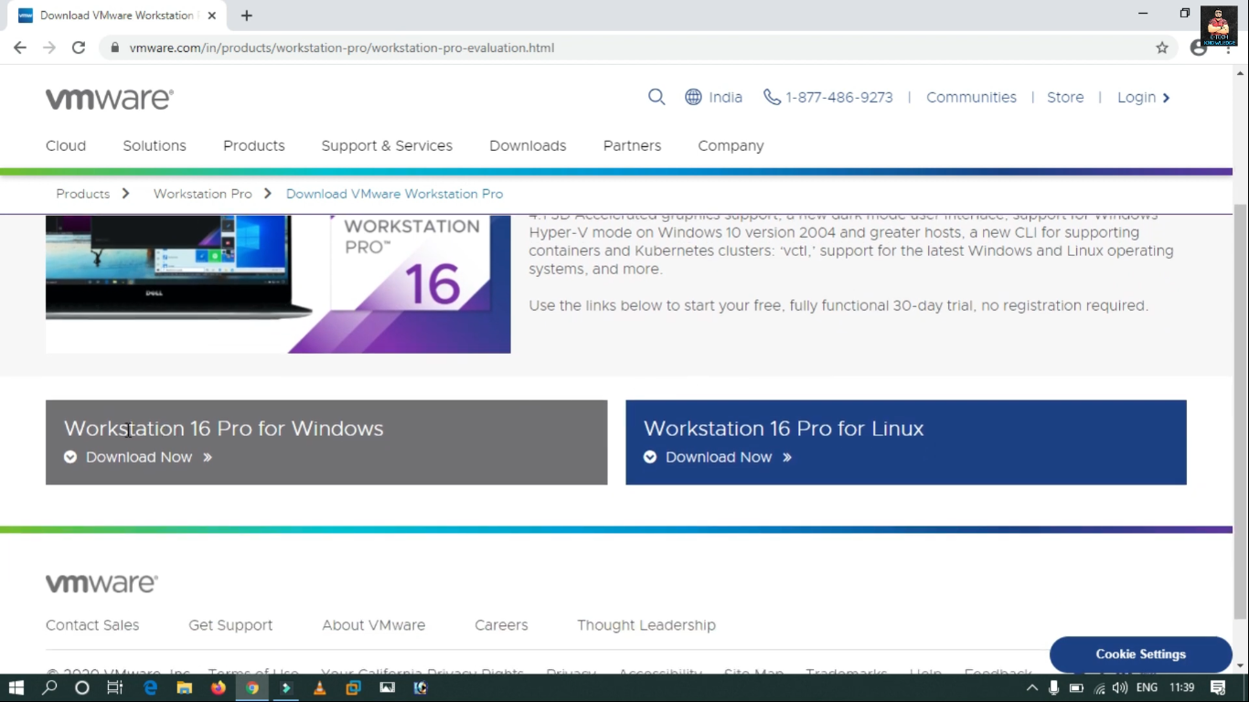

2) Click on the downloaded executable setup file

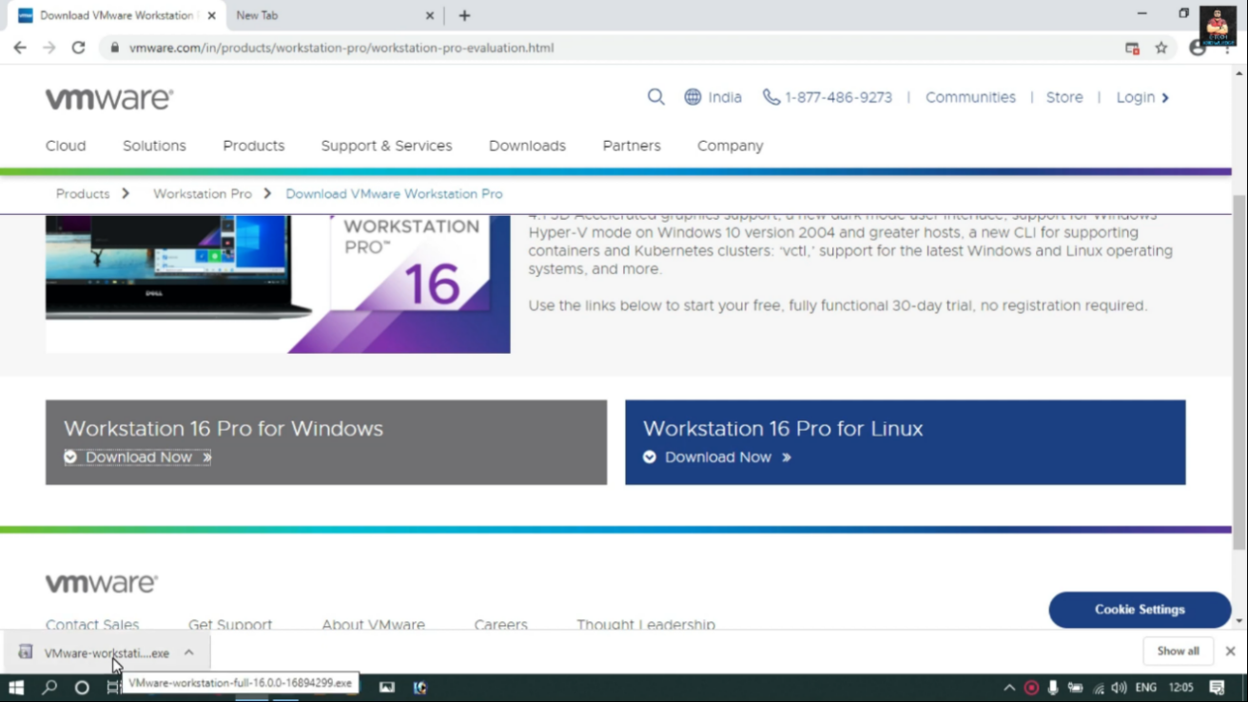

3) VMware Workstation Pro Setup Wizard and Click Next,

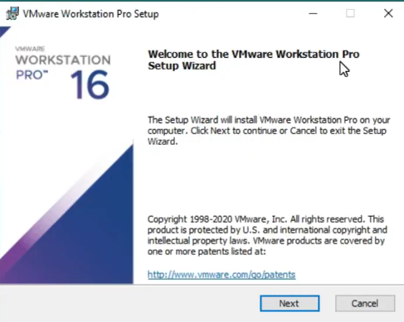

4) Read Terms and Conditions and I click I accept and Click Next,

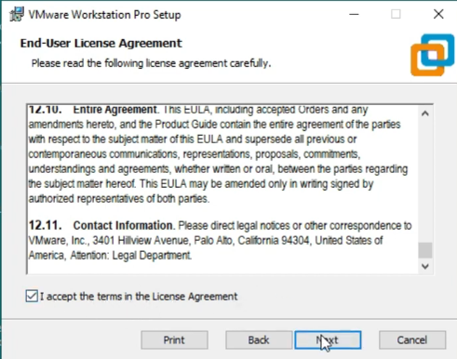

5)Click next,

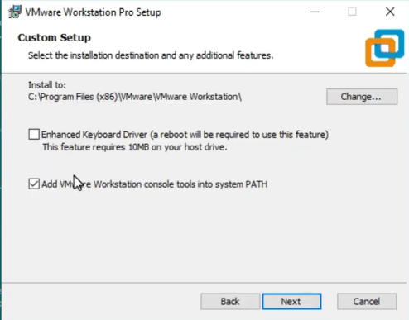

6)check on both boxes and click next,

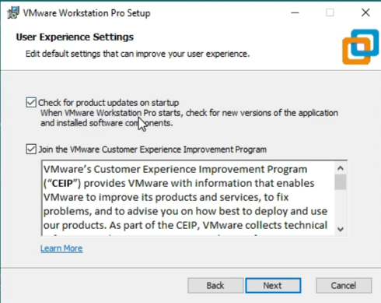

7)Select shortcuts Click next,

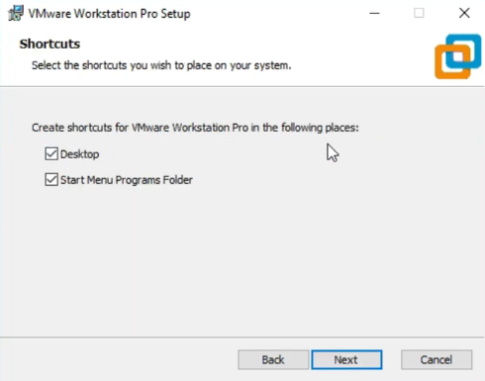

8)VMware Workstation Pro is ready to install, click next

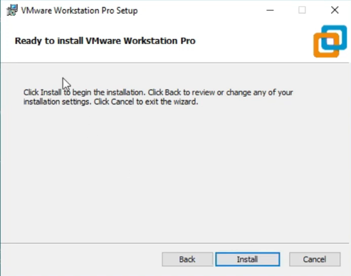

9)The VMware Workstation Pro Installation have been started

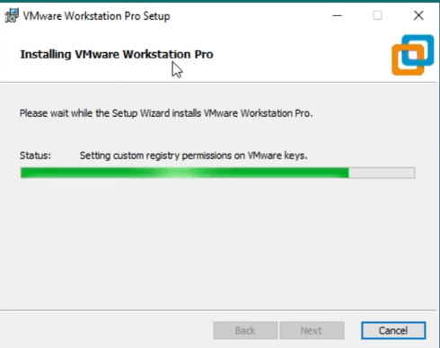

10) VMware installation is completed, click on licence

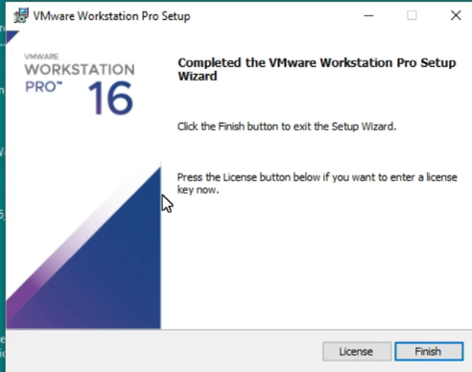

11) Enter Licence key and click next,

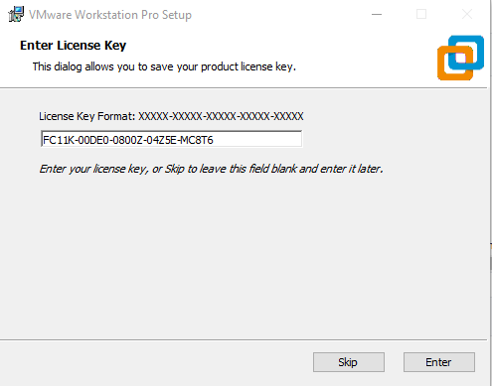

12)VMware 16 Pro successfully Installed and licenced

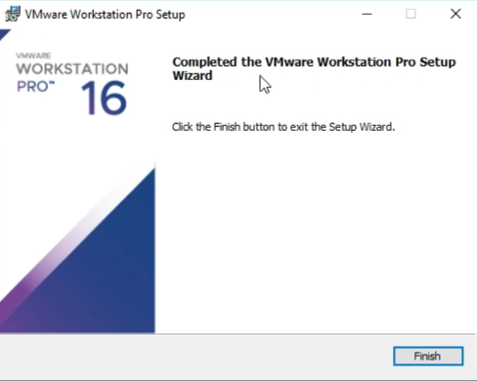

1. **Steps for Creating Ubuntu Virtual Machine in VMware Workstation 16 Pro:**

1)Open VMware Workstation 16 PRO, click on “Create a new virtual machine”

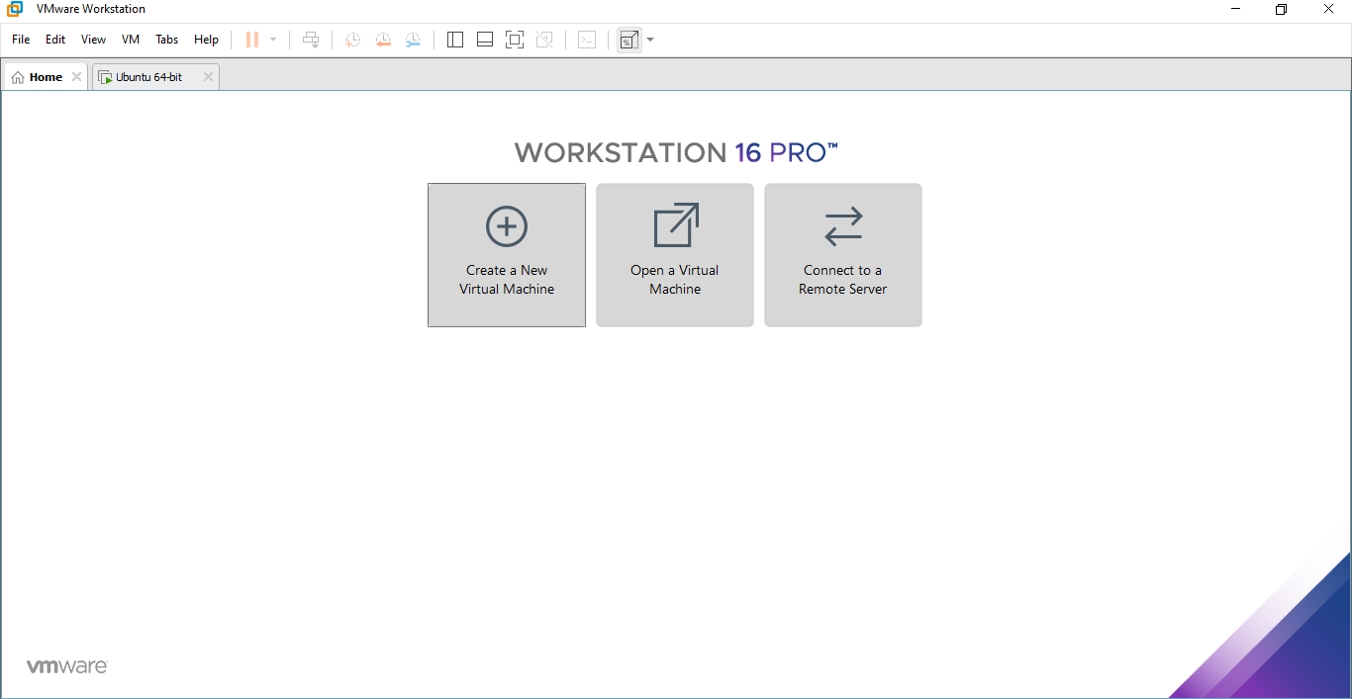

2) New Virtual Machine Wizard Will appear. Click Typical Configuration, click next

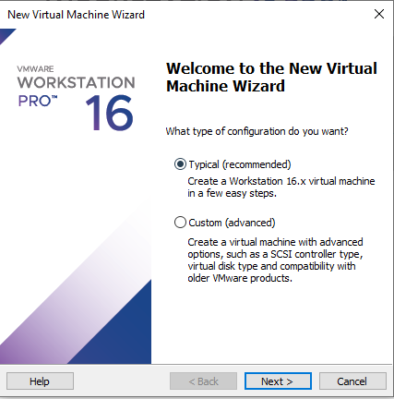

3)Click on Installer disc image file and click on browse and select UBUNTU iso file,

-Ubuntu 64-bit will be detected if you put correct iso image file., Click Next

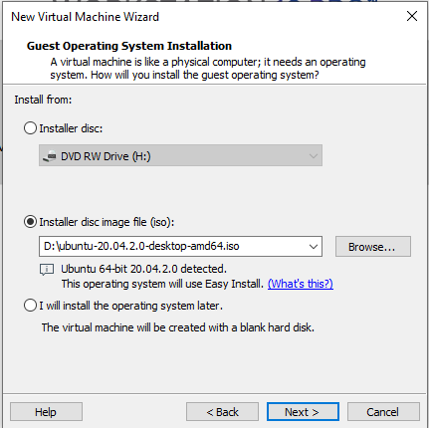

4)Give virtual machine a name and select location where you want to install UBUNTU Virtual Machine.

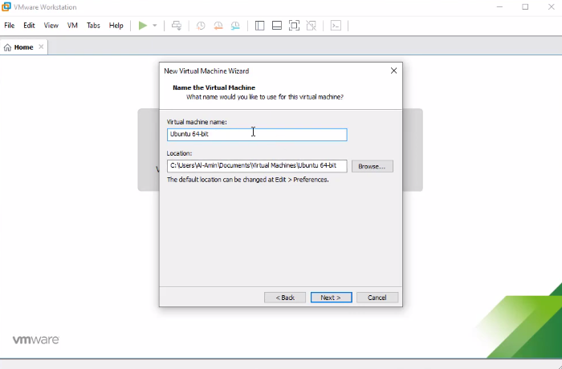

5)Click Split virtual disk into multiple files, and allocate 20 GB space for Ubuntu

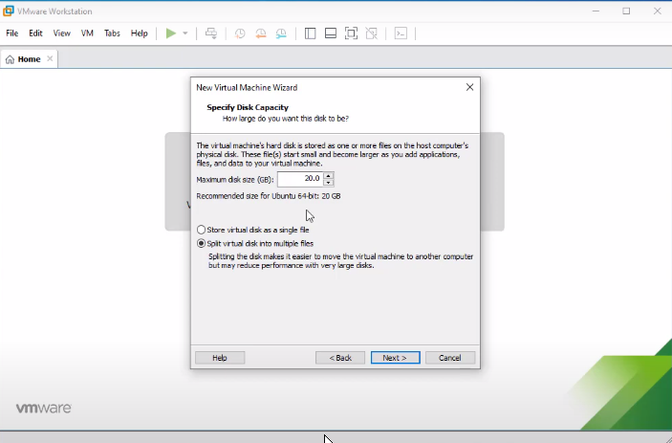

6)Customize hardware and click next

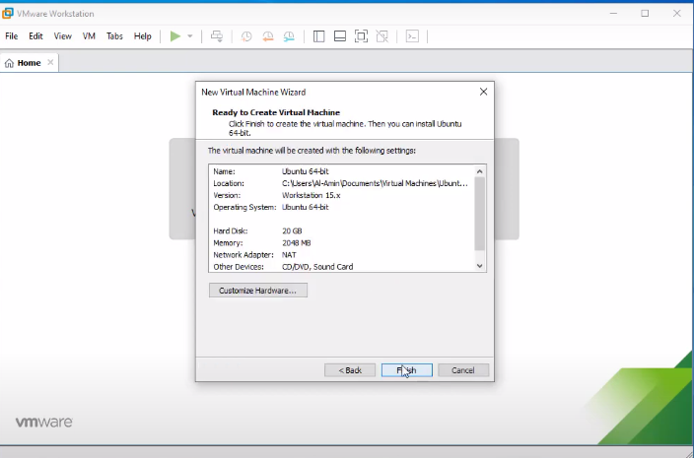

7)Ubuntu Installation has been started

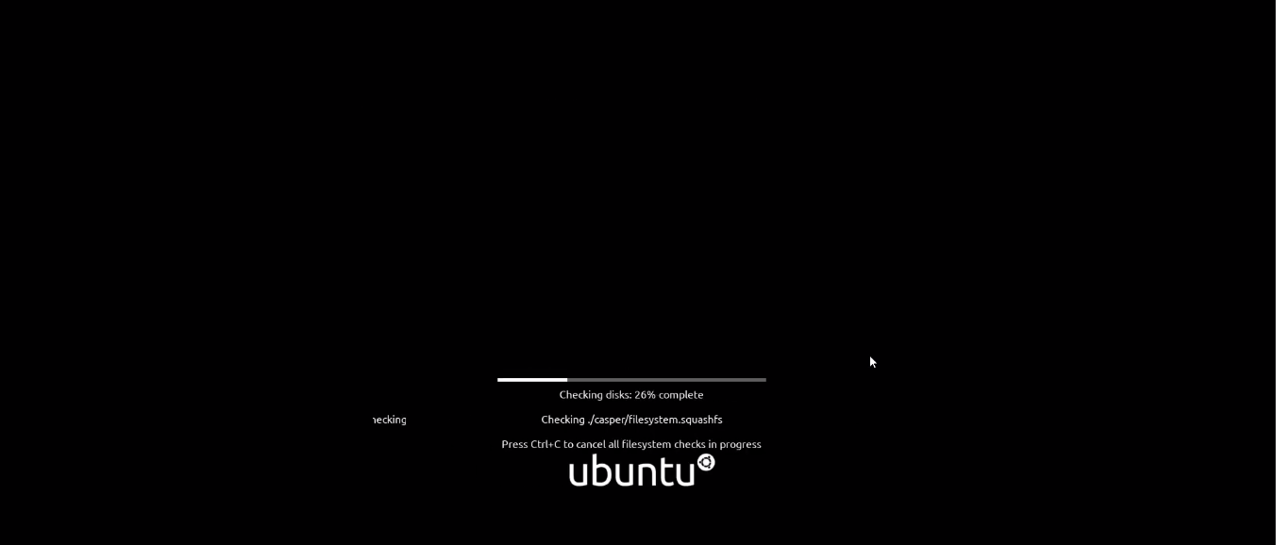

8)Click on English, and click on install UBUNTU

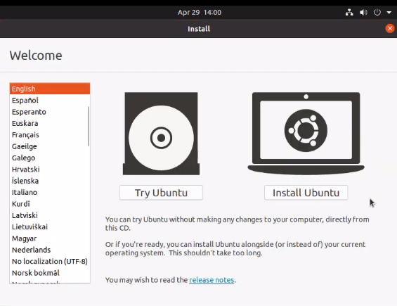

9) Select Keyboard layout, click next

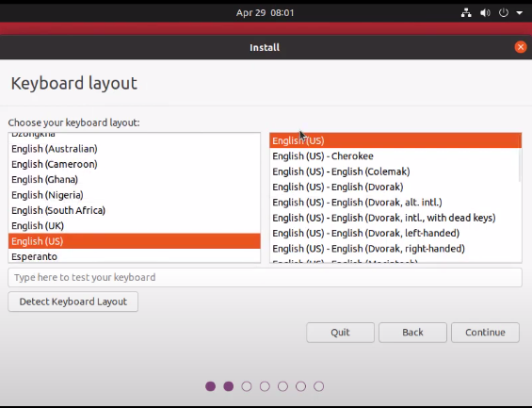

10)Click normal installation, click continue

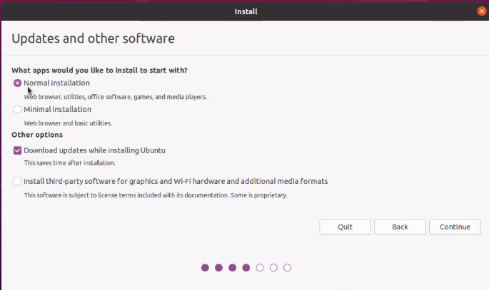

11)Select Region and click continue

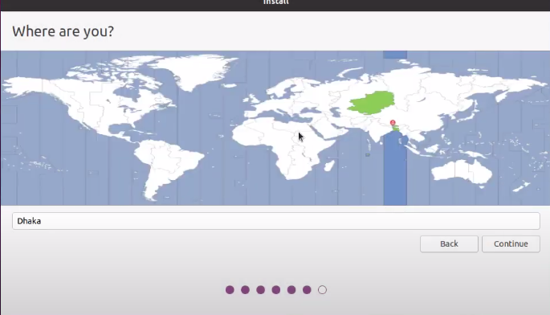

12)Enter Credentials for Ubuntu and click next,

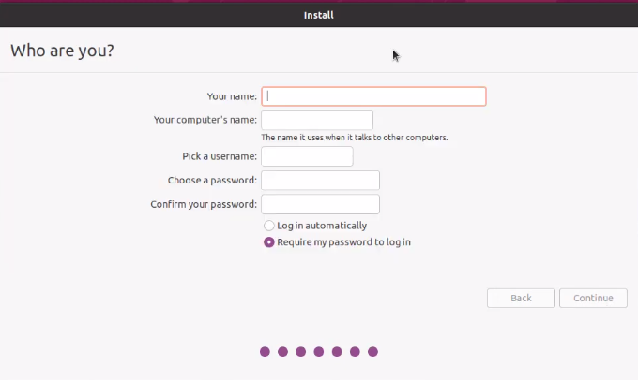

13)Download packages

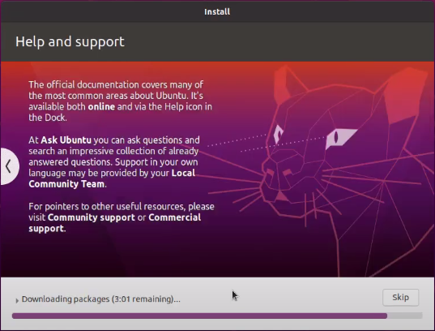

14)Here installation has been completed, click restart now

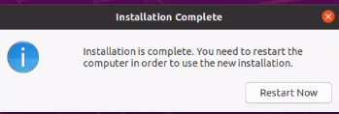

15)Login screen will appear, enter password and click enter

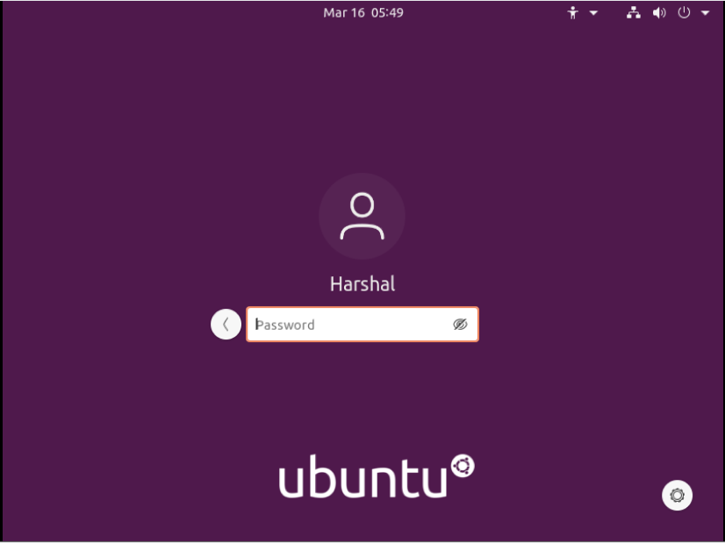

16) Here the desktop is visible, and we are finished with creating Ubuntu virtual machine

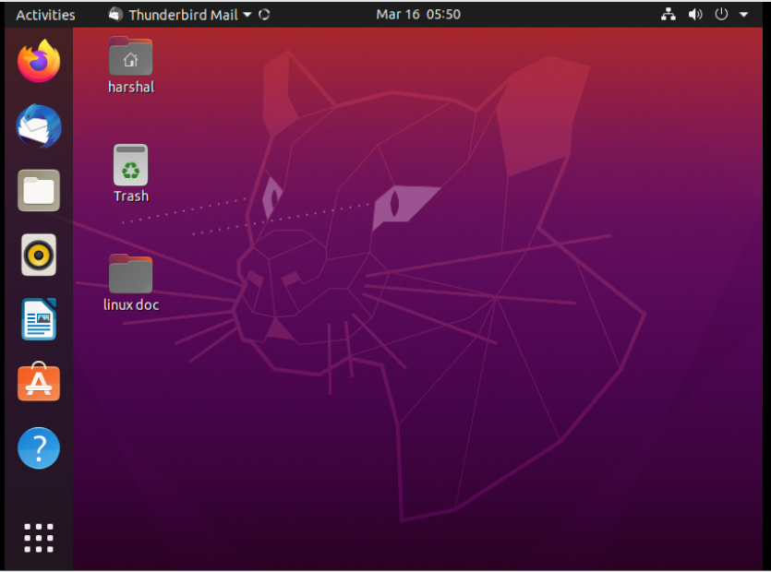

Conclusion:

Practical No: 2

Date of Performing:

Aim: To study file system in linux.

Theory:

## Linux File System Structure

## Linux File System Features

## Types of Linux File System

Practical No: 3

Practical No: 4

Practical No: 5

Practical No: 6

Practical No: 7

Practical No: 8